**THESE NOTES ARE NOT COMPLETE/CHECKED AND COULD DO WITH UPDATING. I’LL GET ROUND TO IT OVER THIS WEEKEND BUT ANYONE FEEL FREE TO AMEND/ADD TO THEM**

**Mobile Media: Local Copy Model**

1. Download file
2. Use resent to recover from errors
3. When file is fully downloaded, play it. This is *non real-time.*

Uses TCP

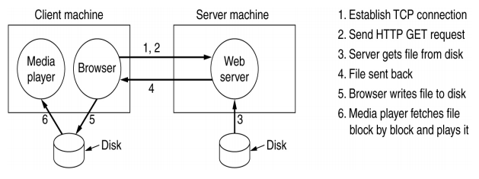

**Streaming Model**

Uses buffering

Start media player as soon as enough data is in the buffer.

Reduces delay and memory requirement.

Buffer smoothes out network jitter.

Allows real-time viewing.

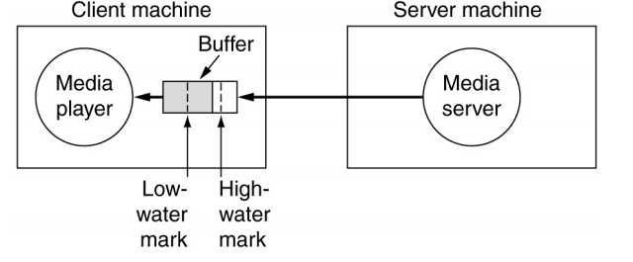

Leaky bucket analogy

“High-water” mark sends a “pause” message to the server, requesting data stop to prevent overflow. Must still be able to handle data during the latency period of the pause message.

when data reaches the buffer’s “low-water” mark, we request a “resume”

**Bit-errors, lost packets**

We don’t usually use TCP for multimedia, as error correction is not as critical as it is in text, and TCP is rather expensive.

A method for coping with lost packets when streaming is to **interpolate** samples between two packets. So one packet has all even times and one has all odd times. This way, if one packet is lost, we can average between the one that made it to smooth over it.

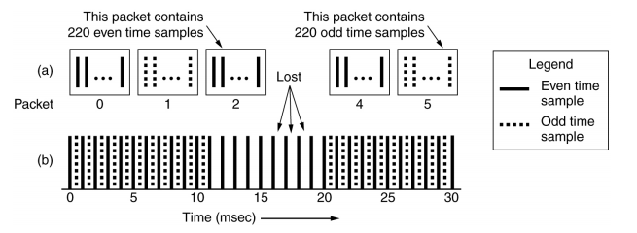

**VOIP Telephony**

Different from streaming, as it is interactive.

There is a round trip time limit (~0.5s) after which, the system is considered unusable.

Cannot use TCP, as any retransmissions will be late.

Instead use RTP, a slightly modified version of UDP. We ‘Fire and Forget’. If it’s lost, it’s lost!

Previous strategy would not work well. Incurs too much delay and bit-errors can be tolerated.

Two forms of VoIP:

* Application Layer (e.g Skype)
* IP Layer VoIP (4G)

**Voice over 4G**

LTE standard supports only IP packet switching.

4 potential ways of handling voice

• **Voice over LTE (VoLTE)**

Voice service delivered as data flows within the LTE data flow.

No need for legacy Circuit Switch voice networks to be maintained.

• **Circuit-switched fallback (CSFB)**

LTE just provides data services,

Voice calls fall back to circuit switched domain.

• **Simultaneous voice and LTE (SVLTE)**

Phone works simultaneously in LTE & circuit switched modes.

LTE mode for data & circuit switched mode for voice.

Distinction exists only in the phone.

• **‘Over-the-top’ (OTT) content services**

Use VoIP apps like Skype to provide voice over LTE IP network.

Voice is still main revenue source, so this is not likely.

LTE standard only supports IP packet switching.

4 potential ways of handling voice.

1. Voice over LTE (VoLTE) - voice delivered as data flows within LTE data flow. No need for old legacy circuit switched voice networks to be maintained
2. Circuit-switched fallback (CSFB) - LTE just provides data, voice calls on *circuit switched* domain.
3. Simultaneous voice and LTE (SVLTE) - Phone works simultaneously in LTE and circuit switch modes. Same as CSFB although the distinction exists only in the phone.
4. Over-the-top content services - use VoIP apps like Skype to provide voice over LTE IP network. However voice is a source of revenue still, so unlikely.

**VoLTE is the future!!**

4G needs to be able to smoothly handover to 3G/2G however to maintain quality under adverse conditions. CSFB is also a backup measure.

Sending to server:

1. Capture the image,sound,etc
2. Compress to reduce data size
3. Add redundancy to enable error correction
4. Transmit data to server

Receiving from server:

1. Receive data from server
2. Detect and correct transmission errors
3. Interpolate or mask un-correctable errors
4. Decompress media information
5. Display/play result

Power trade-offs

* Better image/audio quality -> more data
* More complex compression algos require more power
* More complex error correction algos require more power
* Constant energy/bit, more power required to transmit data. Compression therefore saves power
* Transmission power can be saved by error correction, better ECC allows lower energy/bit

**Coding multimedia signals**

Increase the capacity of radio channels.

* data capacity reduces bit-rate
* *Error Correction Coding (ECC)* increases bit-rate
* ECC reduces transmit power needed, and decreases interference with neighbour cells

Minimise the effect of transmission errors

* use ECC to recover from errors
* block interleave and similar schemes to map burst errors into evenly distributed single errors
* For occasional un-correctable errors, use interpolation to minimise the quality loss

**Dynamic Control**

Radio signals are affected by a variety of factors, reflections off buildings, movements, Doppler shift, sources of interference.

Use feedback to maintain functionality.

We use the feedback to control

* Transmission Power
* ECC Redundancy
* Compression ratio.

**Reminder of 3G-CDMA**

Each bit becomes a pseudo-random sequence of chips. If we know the sequence, we can easily correct. (Lecture 6, mobile networks).

Advantages of CDMA over 2G-GSM(TDMA)

1. TDMA has strict transmission times, CDMA does not, increases spectral efficiency.
2. CDMA allows a flexible allocation of resources. There is no strict limit to the number of users (soft capacity limit)
3. With 2G, channels not being actively used are just wasted. With CDMA, ‘silent’ channels do not use any resources.

**LPC-10**

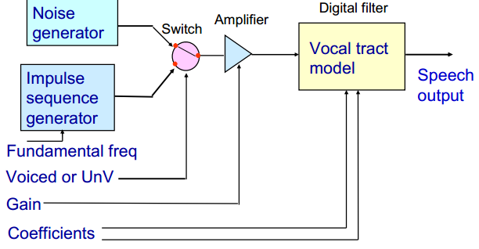

See Workshop 1 notes for LPC and LPC-10.

**Prediction filter**

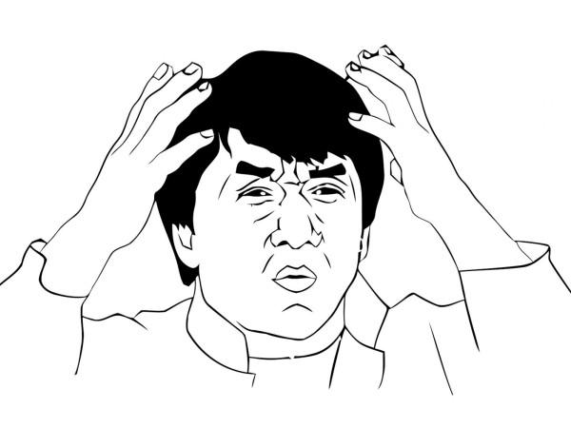

**Voiced & unvoiced speech**

Voiced

* vowels
* resonances which change as a person speak
* “aaa eeee oooo uuuu” - Barry

Unvoiced

* Vocal cords do not vibrate
* Turbulent air flow produces “hissing” sound

**‘Comfort noise’**

In a 2-way telephone conversation, each person may be listening/waiting about 60% of the time.

Discontinuous transmission, is an option for not transmitting ‘silence’, it saves power but a receiver’s phone may sound ‘dead’ due to the lack of background noise.

So receiver inserts artificial BG noise.

We use a Voice Activity Detector (VAD) at the transmitter, which determines when the talker is ‘silent’ and when to insert the BG noise. This is known as ‘comfort noise’.